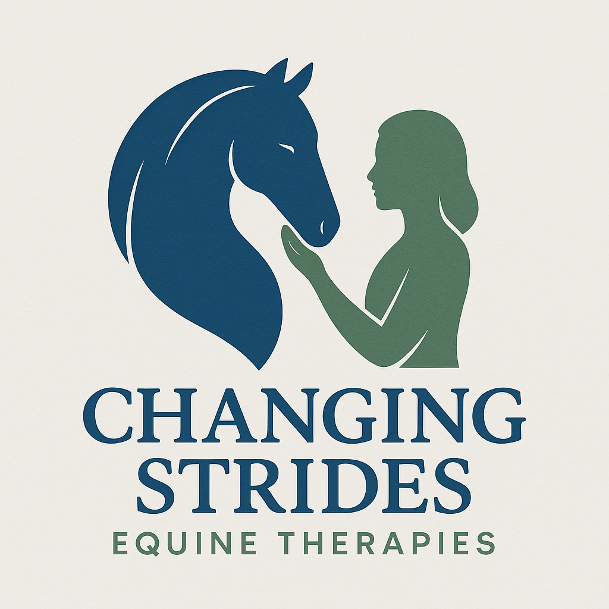

Changing Strides Equine Therapies
My Safeguarding and Behaviour Agreement

Welcome!
We’re so happy you’re here at Changing Strides. We want everyone to feel safe, happy, and respected when spending time with our horses and each other. This agreement is to help you understand what we expect and how we can all help keep things safe and fun.

My Promises
Please read each promise and tick the box when you agree:
☐ I will be kind and respectful to everyone, including the horses.
☐ I will listen to the adults and follow instructions to stay safe.
☐ I will tell a grown-up if I feel worried, upset, or unsafe.
☐ I will try my best and ask for help if I need it.
☐ I won’t hurt anyone or damage anything on purpose.
☐ I will be calm around horses so they don’t get scared.
☐ If someone is being unkind, I will tell a safe adult.

If I Need Help
If I feel worried, unsafe, or something feels wrong, I know I can talk to:
- A grown-up at Changing Strides
- My parent or carer
- A teacher or another trusted adult
There are always safe people here who want to help me

Signatures
I understand this agreement and will do my best to follow it.
Participant Name: __________________________________ Age: ________
Participant Signature: ______________________________ Date: ____________
Parent/Guardian Name: ____________________________
Parent/Guardian Signature: _________________________ Date: ____________
Staff Member Signature: ____________________________ Date: ____________

